Samira Hadid

Digital Marketer

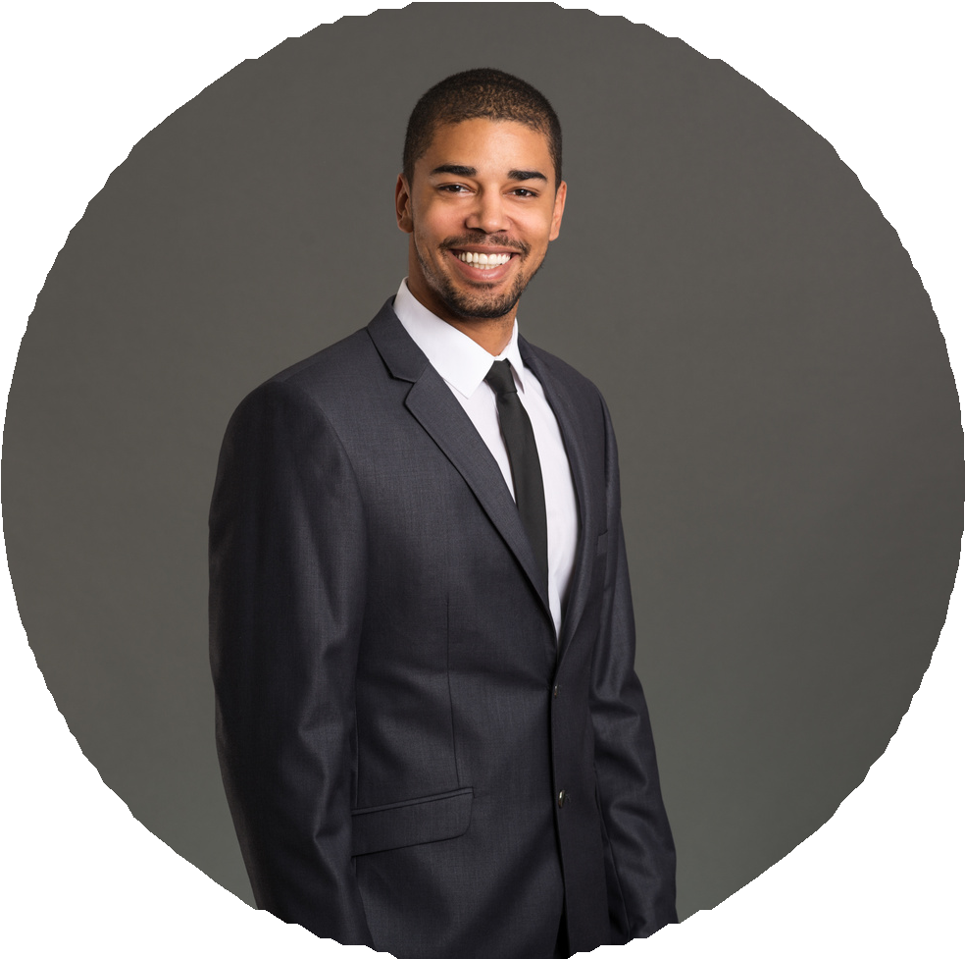

# About me

I am a talented, ambitious and hardworking individual, with broad skills and experience in digital and printed marketing, social media and leading projects.

# Contact

123-456-7890

@reallygreatsite 123 Anywhere st. Any City, ST 12345

# Expertise

Skill 1

Skill 2

Skill 3

Skill 4

Skill 5

# Education

2011 - 2014

School of university

123 Anywhere st., Any City, ST 12345

2015 - 2017

School of university

123 Anywhere st., Any City, ST 12345

# Work Experience

2018 - 2020

Work passionately on customer service in a high volume office. Completed F.A.S.T. customer service training classes.

Maintaining a high average tip thanks to consistent customer satisfaction.

2021- 2022

Work passionately on customer service in a high volume office. Completed F.A.S.T. customer service training classes.

Maintaining a high average tip thanks to consistent customer satisfaction.